Name : Aman sain Sap lD: 500107367 Roll no: R2142220418

Lab Exercise 3: Working with Docker Volumes

Objective:

- Learn how to create and manage Docker volumes.

- Understand how Docker volumes can be used to persist data across container restarts.

- Practice mounting Docker volumes to containers.

Prerequisites:

- Docker installed on your system.

- Basic understanding of Docker commands and container concepts.

Step 1: Create a Docker Volume

Create a new Docker volume:

docker volume create my_data_volume

This command creates a Docker volume named my_data_volume.

Verify that the volume was created:

docker volume ls

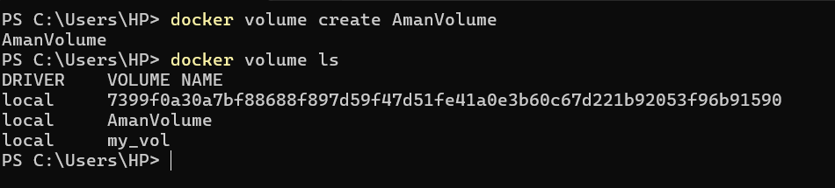
You should see my_data_volume listed among the volumes.

Step 2: Run a Container with the Volume Mounted

Run an Nginx container with the volume mounted:
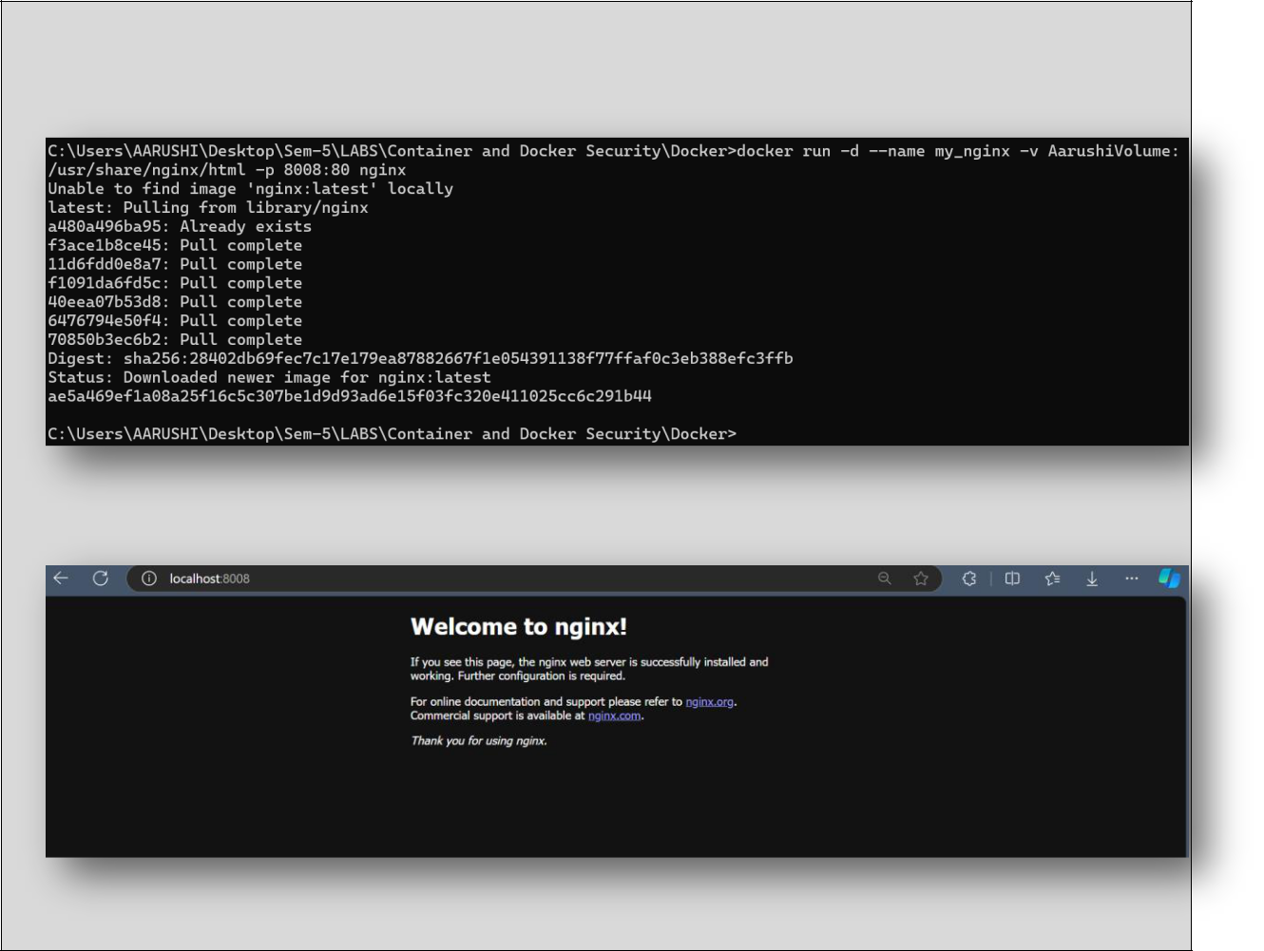

docker run -d --name my_nginx -v my_data_volume:/usr/share/nginx/html -p 8008:80 nginx

This command starts an Nginx container named my_nginx and mounts the

my_data_volume volume to the /usr/share/nginx/html directory inside the container.

Verify that the container is running:

docker ps

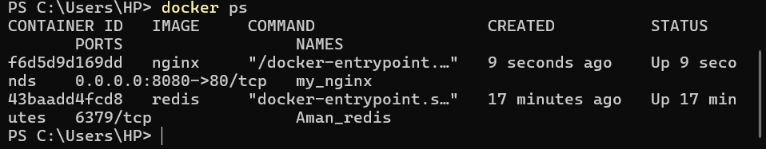

You should see my_nginx listed as one of the running containers.
Step 3: Interact with the Volume

Create a simple HTML file in the volume:
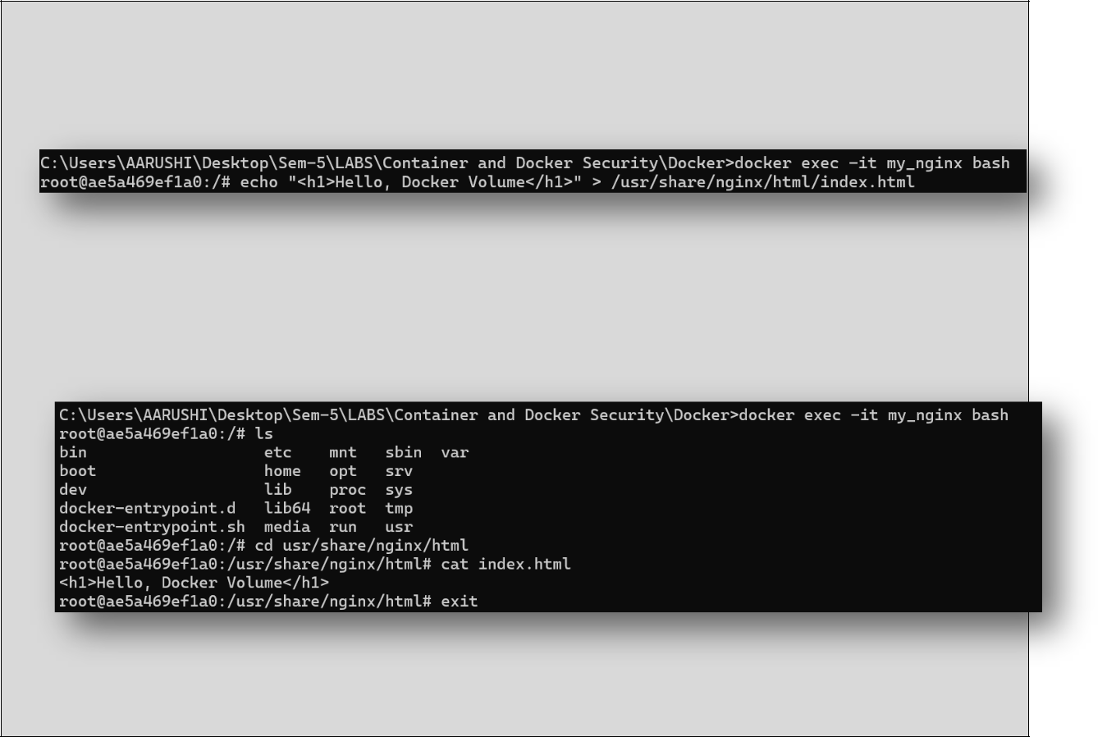

docker exec -it my_nginx bash

echo "<h1>Hello, Docker Volume</h1>" > /usr/share/nginx/html/index.html

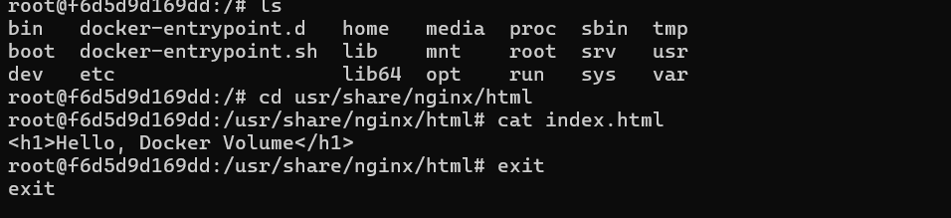

exit

This command creates an HTML file inside the /usr/share/nginx/html directory, which is backed by my_data_volume.

Access the Nginx server to see your file: Open a browser and navigate to http://localhost:8008. You should see the message "Hello, Docker Volume!" displayed
on the page.
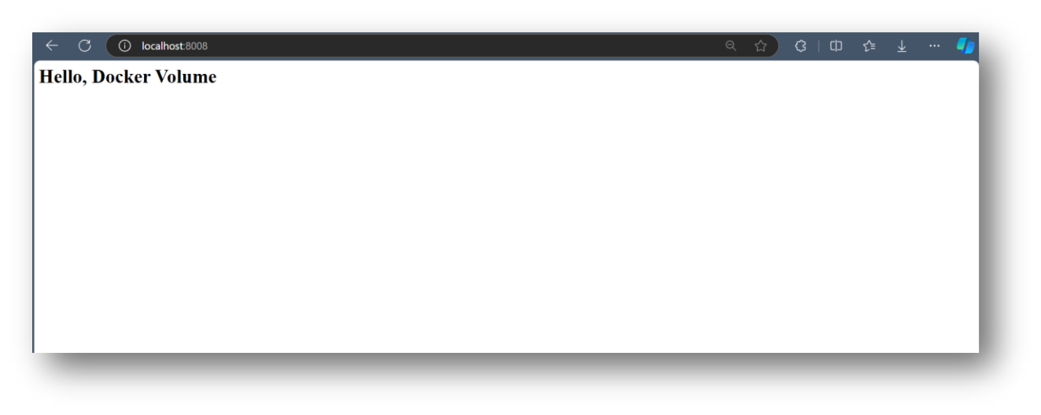

Step 4: Test Data Persistence

Stop and remove the container:
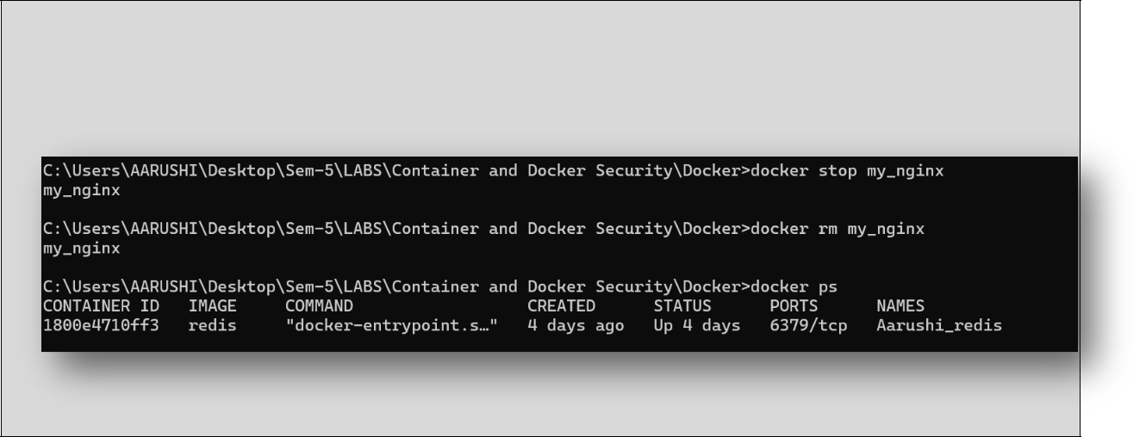

docker stop my_nginx

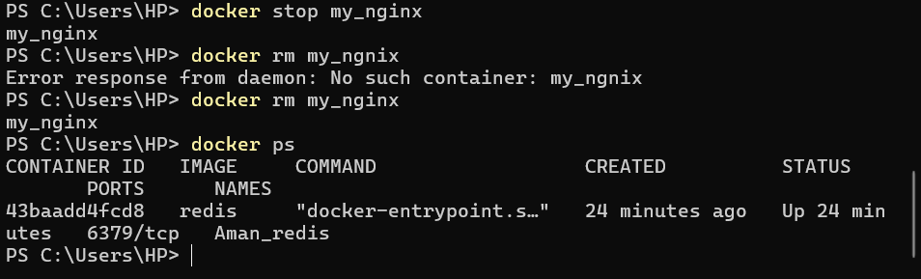
docker rm my_nginx

Run a new Nginx container using the same volume:

docker run -d -p 8011:80 -v my_data_volume:/usr/share/nginx/html nginx
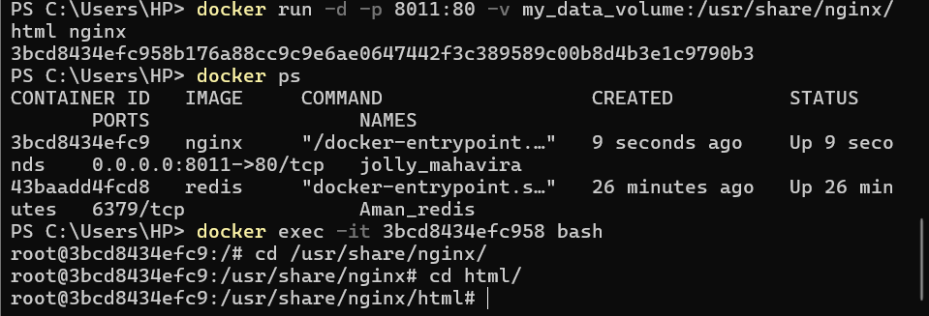

Access the Nginx server again: Navigate to http://localhost in your browser. You should still see the "Hello, Docker Volume!" message, demonstrating that the data persisted across container instances.
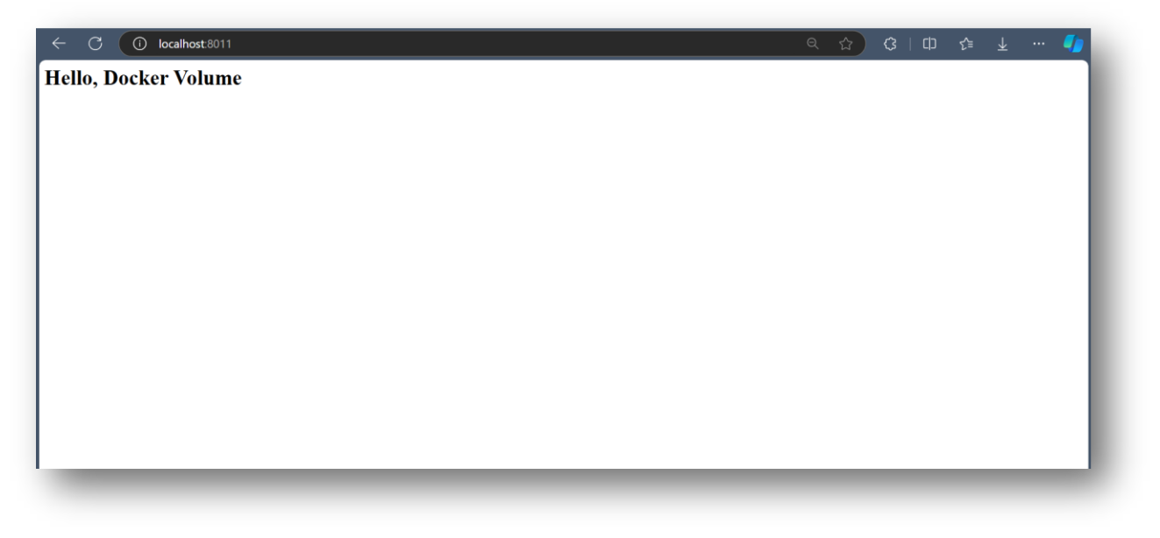

Step 5: Clean Up

Stop and remove the container:

docker stop new_nginx
docker rm new_nginx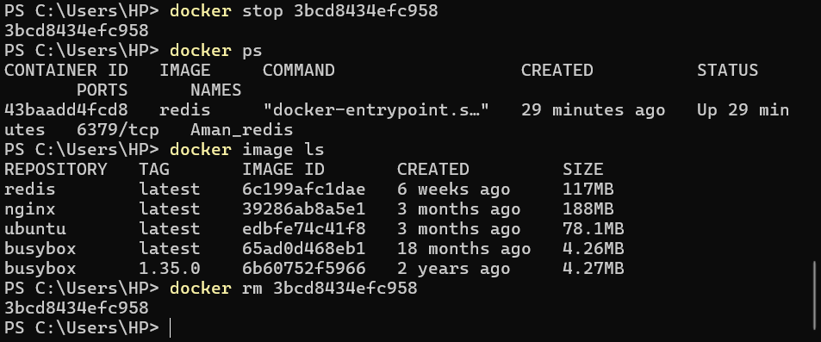

Remove the Docker volume:


docker volume rm my_data_volume

Verify that the volume is removed:

docker volume ls

Ensure that my_data_volume is no longer listed.
